*Under embargo until 8 April at 2pm UK time*

UNIVERSITY

Announce debut album, McCartney, It’ll Be OK, out 20 June 2025 via Transgressive - presave HERE

Release new single/video, “Curwen” - listen HERE / watch HERE

Announce new UK live dates including a sold out London date this week on 10 April at The Blue Basement and London headline on 17 September at George Tavern


Photo Credit: Steve Gullick

“an explosion of energy unlike anything you’ve heard this year" - NME

“‘Title Track’ is a riotous earworm from noise punk’s most promising new band.” - Dork

“a band trying to pummel their way out of a cage” - DIY Mag

“glorious desolation” - So Young

UNIVERSITY, the Crewe-based four-piece formed of Zak Bowker (vocals/guitar), Ewan Barton (bass), drummer Joel Smith and Eddie (mascot), announce their debut album, McCartney, It’ll Be OK, out 20 June 2025 via Transgressive. Today they also share a new single, “Curwen” (listen here).

Recorded with producer Kwes Darko (Sampa The Great, Denzel Curry) at Damon Albarn’s Studio 13 in London, McCartney, It’ll Be OK furthers the extremely exciting beginnings of UNIVERSITY’s 2023 debut EP, Title Track, with the hooks now brighter and more melodic, the breakdowns heavier and the lyrics more refined. The band recorded McCartney, It’ll Be OK totally live, and it retains the delightfully unhinged energy that’s defined their work so far, with everything thrillingly close to falling apart at any minute.

Speaking about the album, Smith said: “There was a conscious choice in the writing to make it more emotionally varied. It encapsulates a wider array of emotions. We’ve got a more light-hearted way of looking at our band now. It puts the sounds from the EP into colour. Because we’re influenced by a lot of emo and music that’s extreme, we realised things can only be so miserable unless you have something to contrast it with. You can only feel the dark properly when you also feel the light. You want to feel all the jumps… like The White Album.”

"Let us go then through the muttering retreats, the stale bedrooms and anemic streets as instant coffee black as cinder leads you to an overwhelming question."

New single “Curwen” sees UNIVERSITY lend their brutally heavy instrumentation and absurdist humour to a scything yet catchy punk track. The new single follows the release of the sardonic “Massive Twenty One Pilots Tattoo”, named after the answer to a game of “what would be the worst tattoo in the world?” and cuts up moments of softer musical clarity with sprawling and incendiary punk rock.

Speaking of the new track, the band said: "Pale sunlight bounds over timid concrete, time jumps like a broken typewriter, the future is past and the past is irrelevant, faces falling in the animal soup of time."

Video director Nina Dellow said: “For me this song feels full of complex energies. I wanted to explore those hard to define tensions in-between, where sound and image meet. Making this piece was instinctive; the movement of an ant, the human body and the rhythms become interchangeable. Shooting on Super 8mm, VHS-C and combining this with 8mm found footage, brings into question notions of time, what is real and how we are connected.”

Listen to “Curwen” here and watch the Nina Dellow-directed music video below.

[video embed: https://youtu.be/aYWRFk70Wa8?si=ZsSGHf-fannSBpmV]

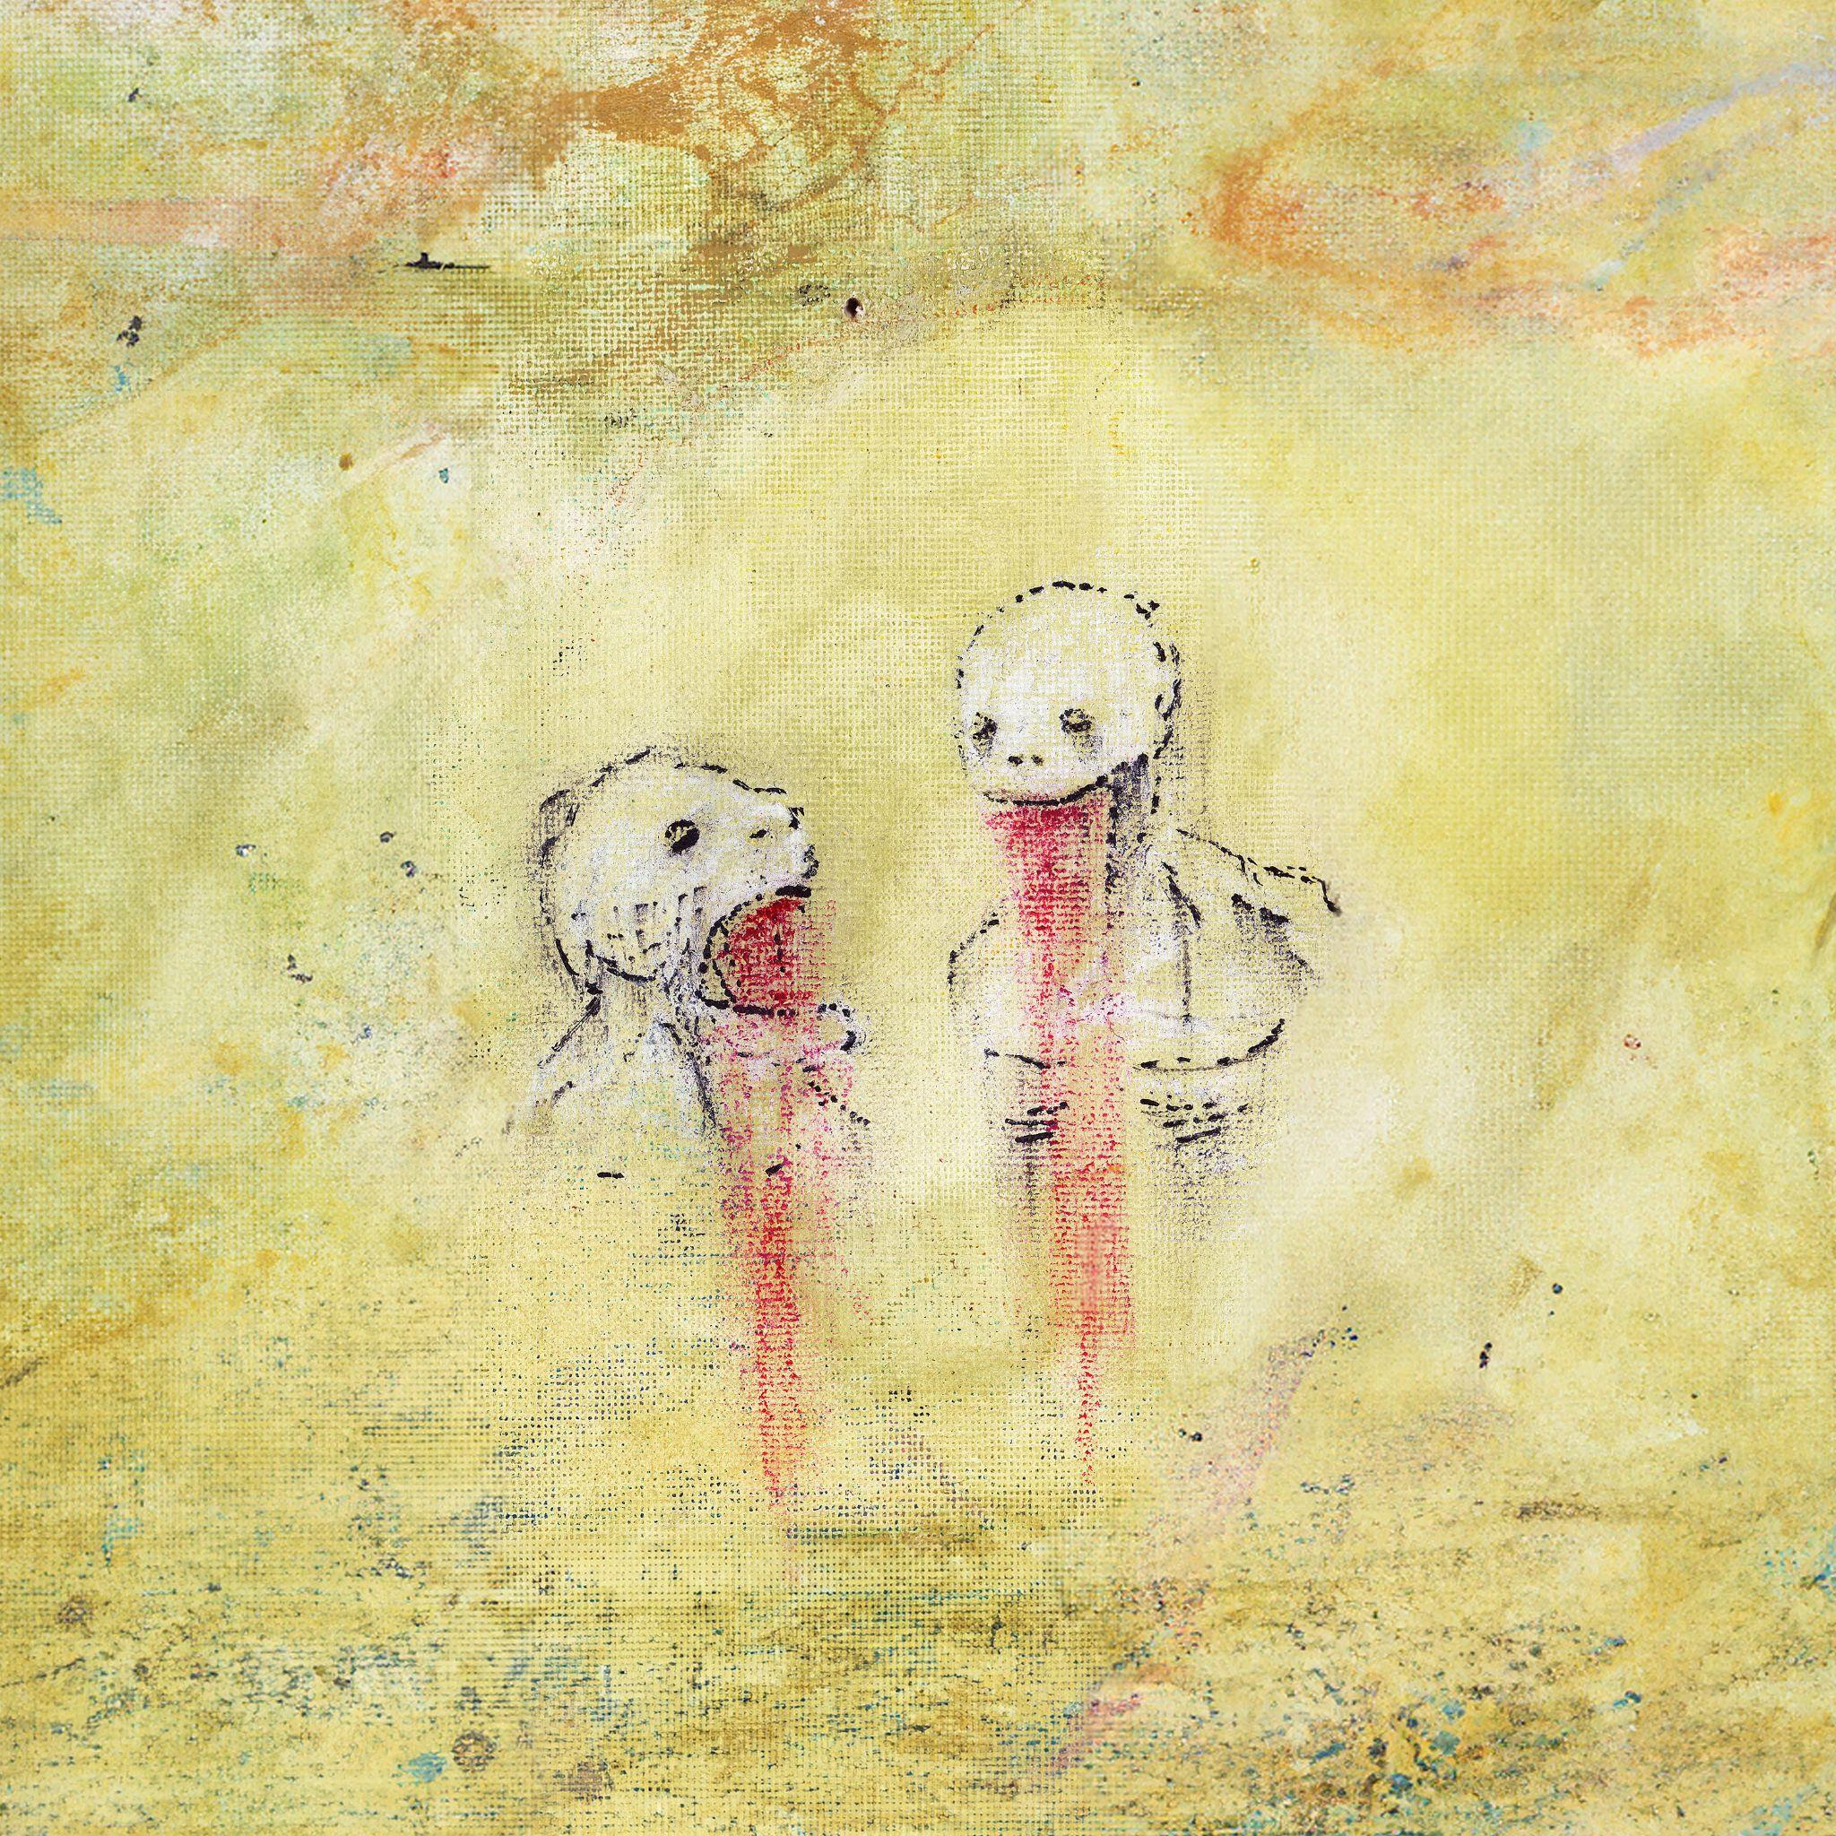
McCartney, It’ll Be OK album art

Tracklisting
Massive Twenty One Pilots Tattoo
Curwen
Gorilla Panic
Hustler’s Metamorphosis
GTA Online
Diamond Song
History Of Iron Maiden Pt. 1
History Of Iron Maiden Pt. 0.5

UNIVERSITY’s sardonic humour melds into their music. After signing to a label and taking the 'business side of their operation' more seriously, they decided to offset this grown-up attitude by pushing their music to more extreme and more absurdist places. “It’s a side effect of taking the rest of it more seriously,” Bowker says, with the band determined to trust their weirdest, funniest impulses.

While the music can be brutally heavy at times, it’s all cut through with the absurdist humour that is also present at the band’s live shows. On stage, they’re joined by balaclava-clad best friend Eddie, whose entire job is to play video games and hold up signs indicating the (often ridiculous and lengthy) title to the next song his mates will play. Of his role in creating the album, Smith says, with however many pinches of salt you’d like to take: “He laid everything down and told us what to record. He’d whip us if we weren’t doing it quickly enough and was pretty horrible to work with to be honest. He was like Frank Zappa, dragging us by the hair back into the studio when we were out having a fag.”

While Beatles references pepper the band’s conversations around the album as well as its title – a misheard lyric from one of its songs – Lennon and McCartney never made anything nearly as weird or energetic as this. Across the album, UNIVERSITY make scything yet catchy punk, gargantuan rock akin to the cult early Biffy Clyro records (“GTA Online”) and blackened ten-minute monsters (“History of Iron Maiden pt.1”, a sequel to a track from the EP in nothing but name).

While they might be throwing out gags and urban myths out in all directions, the only thing truly undeniable is the remarkable energy of UNIVERSITY’s music, and the strength of their songwriting. Across its eight tracks, McCartney, It’ll Be OK travels to a superb amount of sonic landscapes, and is the heaviest album you’ll hear this year that is also this much fun.

UNIVERSITY’s debut release, the 2023 5 x track EP, Title Track, featured the songs “King Size Slim”, “Notre Dame Made Out Of Flesh” and “Egypt Tune”. Title Track saw praise for its unwavering explosive sound and energy, described by Dork as “a riotous earworm from noise punk’s most promising new band” and by NME as “an explosion of energy unlike anything you’ve heard this year".

Following standout shows at The Great Escape, Green Man, End of The Road, Mutations Festival, Pitchfork Festival Paris, and more recently multiple appearances at this year's SXSW, these charismatic young upstarts now gear up for a run of newly announced UK dates including an appearance at Manchester’s Outbreak Festival and a headline show at London’s George Tavern (tickets here). UNIVERSITY also play a sold out London show this week on 10 April at Third Man Records’ The Blue Basement. See the full list of dates below.

10 April 2025 - London, UK @ Third Man Records - The Blue Basement - sold out
16 May 2025 - Amsterdam, NL @ Paradiso - London Calling
14 June 2025 - Manchester, UK @ Outbreak Festival
6 September 2025 - Asten-Heusden, NL @ Misty Fields Festival
17 September 2025 - London, UK @ George Tavern

Follow UNIVERSITY:
https://www.instagram.com/abandcalleduniversity/?hl=en
https://open.spotify.com/artist/2TDMep1IfMAASZxbC5FAo5?si=uqgWNWihQvuAkTEhzJEDIQ&nd=1&dlsi=59c444678dfb415d
https://www.youtube.com/channel/UC2xoJKRSPMLOGQZL1eHafPA

For PR enquiries please contact:
Elliot Willcocks and Jodie Banaszkiewicz at Stay Golden PR: elliot@staygoldenpr.com / jodie@staygoldenpr.com



